

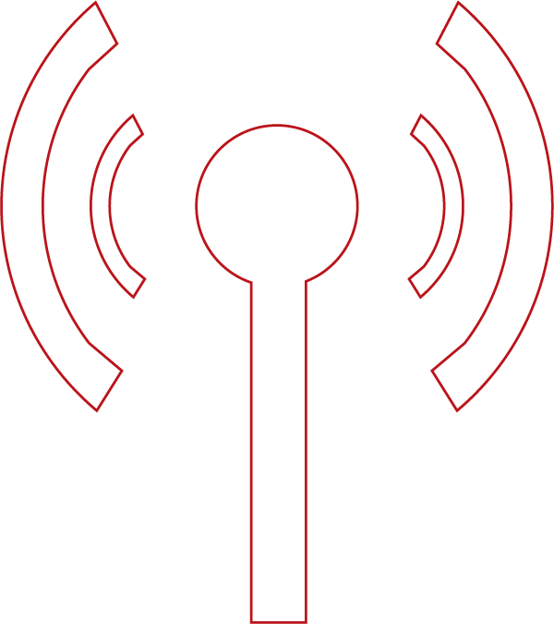


sec\\\



Simplified Collections

Contents
Introduction 1
About this document 1
Simplified Follow-up Template 2
Screen Explanation 2
Manual 2
Renewals 7
Auto 10
Trail Plan 13
Usage 15
True Prepaid 17
Profile Options 18
Invoice Payment Due Days 18
Capture Own Hardware In Order Booking 18
Grace Period 19
Jobs 20
Simplified Collection New 20
Mail Daemon 20
Generate Payment Request 20
Process Payment Request 21
Process Response Payment Request 21
Follow Up By Usage 21
Follow Up By Trial Expiry 22
Manage Notifications 23
Support 24
Copyright 25

Introduction

The Collection is a term used by a business when referring to money owned to that business by a Customer.
In every business, there are Good Customers and Bad Customers. The Good Customers always pay their outstanding bill amount in time to their Service Providers or to the businesses from where they purchase or buy the service, whereas the Bad Customers are the Customers who don’t pay their bills in time to the Service Provider or business even after their paying due dates.
Due to bad customers, businesses undergo a lot of challenges and face a significant loss in terms of business revenue. So, to handle these bad customers, and to cover up the fore coming losses due to bad customers, the Collections process is introduced.
As part of this process, Magnaquest SURE! has introduced a comprehensive and user-friendly approach named Simplified Collections in dealing with the collections. As part of this Simplified Collections process, a new screen Simplified Follow-up Template is introduced, where from this screen, the User can define the follow-up process in form of configuring the Remainder Email/SMS for different events like Contract Renewals, Auto, Trial Plan, Usage, and True Prepaid.
This style of follow-up process helps the business in maintaining the one-to-one relationship with the Customers, as the business is in constant touch with the Customers on various service-related information like Customer’s Payment due date, Renewal date reminders, Data Usage Warnings, etc. in form of configured reminder Emails/SMS.

About this document

This document helps the User to understand the Simplified Follow-up Template screen and its usage along with the related information with respect to the process like Profile Options used, Jobs used, etc.

Simplified Follow-up Template

The Simplified Follow-up Template screen is used to configure the follow-up process and define the actions for the events like Manual, Renewals, Auto, Trial Plan, Usage, and True Prepaid.
Follow these steps:

- On Settings, click Billing & Receivables, click Collections, and then click Simplified Follow-up Template.
The Simplified Follow-up Template screen appears with the below follow-up events
- Manual
- Renewals
- Auto
- Trial Plan
- Usage
- Trial Period
- To configure the collection process, click the required event (Manual, Renewals, Auto, Trial Plan, or Usage) and do the necessary configuration.
- Once the details are configured, click Save to save the configured details.

Screen Explanation
As part of the Collection follow-up process, the following actions (shown in tables) can be configured to the events:

Manual
Manual: This process is for the Perpetual Contract Customers who don’t have the auto-payment facility like Standing Instructions, etc.
From here, you can configure the Collection details like… Collection Period, Due Reminder Frequency, Suspend Subscriptions, Over Due reminder Frequency, Reminders after Disconnection, and Collections specific actions for the Subscriptions and Invoices when the Collection Period ends, etc.
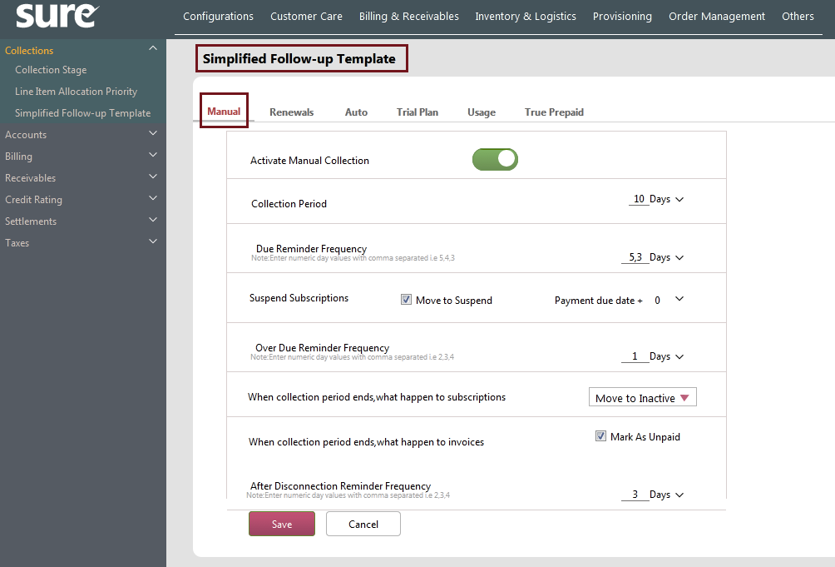
Fields Explanation:

Action | Explanation
Activate Manual Collection | Toggle the switch ON to enable the Collections’ manual process.  Toggle the switch OFF to disable the process.
Collection Period | It implies the overall collection days excluding the Payment due date for the Manual process.  Example: 10 Days.
Due Reminder Frequency | Provide the Due Reminder Frequency value in days. Here the ‘No. of days’ value is Prior ‘No. of days’ value for sending the reminders.  Example: 5, 3 Days.  If the Customers’ Payment Due date is 10th May, then with the above-configured values, the Payment-due reminder mails will be sent to the Customers on 5th and 7th May.  I.e. 5 and 3 days prior to the payment due date
Suspend subscription  (Move to Suspend &  Payment Due Date +) | The Suspend Subscription has two values:  - Move to Suspend (Check box): Select the Check box to have the Provisioning suspend.  Note: If Move to Suspend check box is selected, then you will have only one value i.e. Move to Inactive in the when collection period ends, what happen to subscriptions list.  If this check box is cleared, then another value Retain as Active is available along with the Move to Inactive value in the when collection period ends, what happen to subscriptions list.  - Payment Due Date +: This denotes the grace period days after which the Suspend action is taken. (Based on check box selection)  Example: If the Customer’s Payment due date is 10th May and If the Move to Suspend check box is selected with Payment Due Date + value as 0 (Zero), then the Customer’s provisioning is suspended the next day i.e. on 11th May.  In the same way, if the Payment Due Date + value is 1, then the suspension will happen on 12th May.
Over Due Reminder Frequency | This is for the Suspended Customers. In other words, if you want to still send reminder mails to the Customers who are suspended then provide the No. of days’ value here.  Example: 1 Day.  If the Customer’s payment due date is 10th May, and the Provisioning is suspended on 11th May. So, to send the remainder mails for the Suspended Customers, the Over Due Reminder Frequency field is used.  Here, since the value of Over Due Reminder Frequency is 1, the remainder mail is sent on 12th May (i.e. after the suspension date).
When collection period ends, what happen to subscriptions | From the list, select the required action.  Example: If Move to Inactive is selected from the list, then after the end of the collection period (Example: 10 days) the Subscription will be moved to an Inactive state.  Note: The values in this list depend on the Move to Suspend check box’s selection.
When collection period ends, what happen to Invoices | Select Mark as Unpaid check box to mark the Invoices as Unpaid after the end of the collection period.
After Disconnection Reminder Frequency | Provide the value in days to send reminders for the disconnected customers.  Example: 3 Days.  Here, the reminder mail is sent to the Customers after 3 days of the disconnection.

Points:

- The Profile Options related to this Manual action are

- Invoice Payment Due Days,
- Capture Own Hardware In Order Booking
- Grace Period

Note: Configure these profile options based on your requirement.

- The Notifications related to this Manual action are configured from the Manage Notifications screen.

- Payment Due Reminder
- Before Payment Due Reminder After
- Suspend Subscriptions
Note: Toggle the above notification switch to ON for sending the configured notification.

- The Jobs related to this Manual action are:

- Simplified Collection New
- Mail Daemon

Renewals
This process is for the Prepaid Contract Customers whose contracts are about to expire.
From here, you can configure Collection Period days for Renewals, Renewal Reminders (Before and after), and with grace period days after the Renewal expiry date.

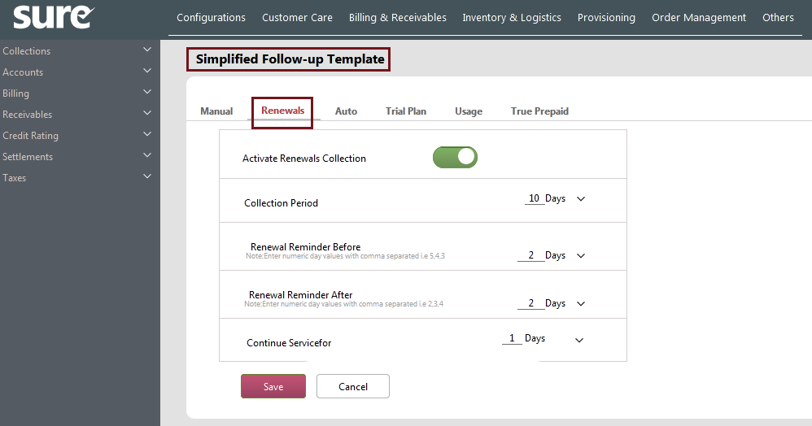

Fields Explanation:

Action | Explanation
Activate Renewals Collection | Toggle the switch ON to enable the Collections’ Renewal process.  Toggle the switch OFF to disable the process.
Collection Period | It implies the overall collection days excluding the Payment due date for Renewal process.  Example: 10 Days.
Renewal Reminder Before | Provide the Renewal Reminder Before value in days. Here the ‘No. of days’ value is Prior ‘No. of days’ value for sending the reminders.  Example: 5, 3, 1 Days.  If the Customers’ Renewal Due date is 30th June, then with the above-configured values, the before reminder mails for renewal are sent on 25th, 27th, and 29th of June.  I.e. 5, 3, 1 day prior to the renewal due date.  Note: The batch jobs (given below in Points) should run in order to send the remainder mails on the configured dates.
Renewal Reminder After | Provide the Renewal Reminder After value in days. Here the ‘No. of days’ value is After ‘No. of days’ value for sending the reminders.  Example: 1, 3, 5 Days.  If the Customers’ Renewal Due date is 30th June, then with the above-configured values, the after reminder mails for renewal are sent on 1st, 3rd, and 5th of July.  I.e. 1, 3, 5 days after to the renewal due date.  Note: The batch job (given below in Points) should run in order to send the remainder mails on the configured dates.  (The reminders are sent only the renewal due Customers.)
Continue Service for | This denotes the grace period days for which the Service is to be continued after the Renewal expiry date.  Example: 2 Days.  If the actual renewal date of the Customer is 10th June and Continue Service for value is 2 days, then the Customer is given 2 extra days for renewing the plan. Here, the service is continued till 12th June.
Points:

- The Notifications related to this Renewals action are configured from the Manage Notifications screen.

- Renewal Reminder After
- Renewal Reminder Before

Note: Toggle the above notification switches to ON for sending the configured notifications.

- The Jobs related to this Renewals action are:

- Simplified Collection New
- Mail Daemon

Auto
This collection process is for Perpetual Customers who have Standing Instructions as a Payment method.
Here, you can define the Collection Period days (i.e. Max follow-up days), Retry Frequency, and Collections specific actions for the Subscriptions and Invoices when the Collection Period ends, etc.
Scenario: While running the batch jobs, some auto-payment transactions (Payments via Standing Instructions) may fail due to various reasons like lack of funds, network issues, card expiry, etc. In such cases, the Customer should be intimated of the Payment failure.
From this Auto Process, you configure the details like Retry Frequency for the failed records. The Retry Frequency is nothing but the days after which the failed records (Status F) are re-processed.
Example: If the Retry Frequency value is 2 days, then the failed records (Status F) of the auto-payment transactions are picked after 2 days for re-processing)

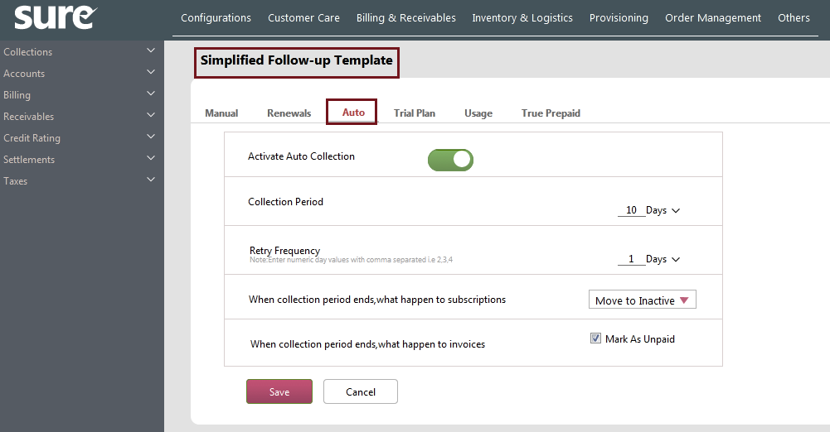

Fields Explanation:

Action | Explanation
Activate Auto Collection | Toggle the switch ON to enable the Auto-Collection process.  Toggle the switch OFF to disable the process.
Collection Period | It implies the overall collection days excluding the Payment due date for Auto-Collection process.  Example: 10 Days.
Retry Frequency | Provide the Retry Frequency value in Days.  Example: 2 Days.  Since the Retry Frequency value is 2 days, the unprocessed collection records are picked by the scheduler after the 2 days for reprocessing.
When collection period ends, what happen to subscriptions | From the list, select the required action.  Move to Inactive or Retain as Active  Example:  - If Move to Inactive is selected from the list, then after the end of the collection period (i.e. 10 Days) the Subscription will be moved to Inactive state.  - If Retain as Active is selected from the list then after the end of the collection period (i.e. 10 Days), the Subscription is retained as Active.
When collection period ends, what happen to Invoices | Select Mark as Unpaid check box to mark the Invoices as Unpaid after the end of the collection period.  If the check box is not selected then the Invoices are not marked as Unpaid after the end of collection period.
Points:

- The Profile Options related to this Auto action is:

- Invoice Payment Due Days

Note: Configure the profile option based on your requirement.

- The Notifications related to this Auto action are configured from the Manage Notifications screen.
- Payment Success
- Payment Failure

Note: Toggle the above notification switch to ON for sending the configured notification.

- The Jobs related to this Auto action are:

- Generate Payment Request

- Process Payment Request
- Process response payment request

Trail Plan
This collection process is used to send reminder Mail/SMS to the Customers whose trial plan is about to expire.
If the value (Number of days) given in this process is 5, then the reminder is sent 5 days before the trail plan expiry.
Note: You can also add a new Reminder row by clicking link.
From here, you can also set the action for the event like what happens next when follow-up ends.
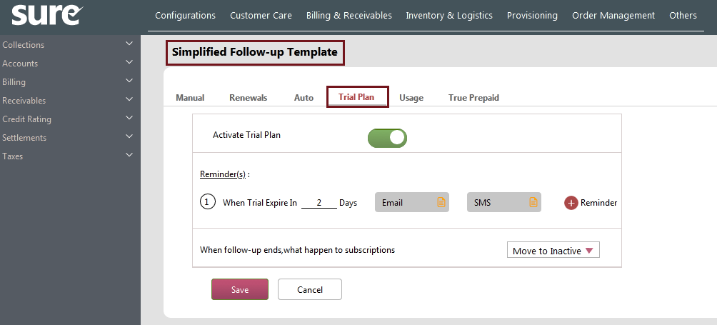
Fields Explanation:

Action | Explanation
Activate Trial Plan | Toggle the switch ON to enable the Collections’ Trial Plan process.  Toggle the switch OFF to disable the process.
Reminder(s):  When Trial Expire In ___ Days | Provide the Trial Plan Expiry day value here.  Example: 2 days.  Here, the Customer is communicated via Email/SMS before 2 days.  Note: The batch job should run in order to send the remainder mails on the configured dates.
When follow-up ends, what happen to subscriptions | From the list, select the required action.  Example: If Move to Inactive is selected from the list, then after the end of the collection period the Subscription will be moved to an Inactive state.

Points:

- The Notifications related to this Trial Plan action are configured from the Manage Notifications screen.

- Trial Plan Reminder

Note: Toggle the above notification switch to ON for sending the configured notification.

- The Jobs related to this Trial Plan action are:

- Follow Up By Trial Expiry
- Mail Daemon

Usage
This collection process is used to send reminder Mail/SMS to the Customers whose data usage is about to exhaust. The value given in this process would be the cut-off % value for the data usage in sending the reminder mails.
Example: If the value (Data Usage Percentage) given in this process is 90, then once the Customer’s data usage reaches 90%, then the remainder Mail/SMS is sent to the Customer about the data usage.
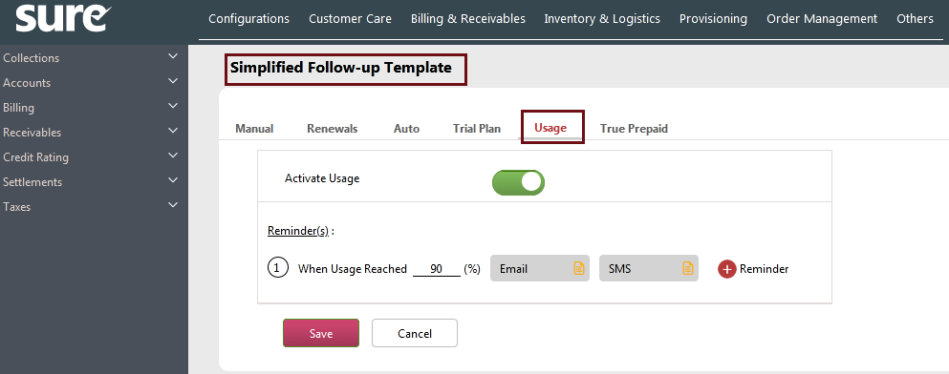
Fields Explanation:

Action | Explanation
Activate Usage | Toggle the switch ON to enable the Collections’ Usage process. Toggle the switch OFF to disable the process.
Reminder(s):  When Usage Reached ___ (%) | Provide the maximum usage percentage value for sending the data usage reminder.  Example: 90 %.  Here, Once the Customer’s data usage reaches 90%, then the configured remainder mail/SMS is sent to the Customer about their data usage.  Note: The User can use for adding multiple Usage Reached Percentages.
Points:

- The Notifications related to this Usage action are configured from the Manage Notifications screen.

- Usage Reminder
Note: Toggle the above notification switch to ON for sending the configured notification.

- The Jobs related to this Usage action are:

- Follow Up By Usage
- Mail Daemon

True Prepaid
This process is used to send reminder Email/SMS to the Customers whose True Prepaid plan is about to expire. Here, you can define the Collection Period days i.e. Max follow-up days, along with the number of days (before) for reminder follow-ups.
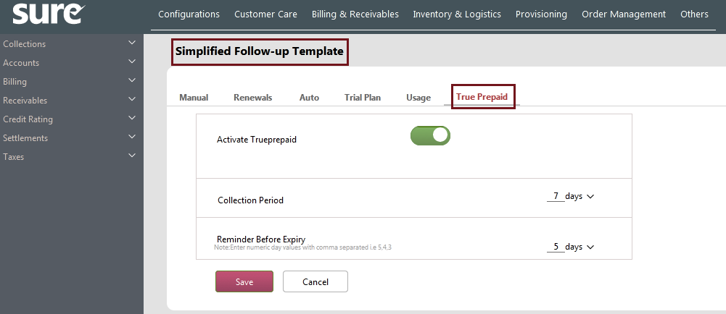
Fields Explanation:

Action | Explanation
Activate Trueprepaid | Toggle the switch ON to enable the Collections’ True Prepaid process.  Toggle the switch OFF to disable the process.
Collection Period | It implies the overall collection days excluding the Payment due date for True Prepaid process.  Example: 7 Days.
Reminder Before Expiry | Provide the Reminder Before Expiry value in days.  Example: 5 Days.  Here, the reminder mail is sent to the Customers before 5 days about the true prepaid plan’s expiry.

Profile Options

Following are the profile options with respect to Simplified Collections:

Invoice Payment Due Days
Use this profile option to add the due days to the system-generated invoice date for deriving the payment due date.
With this derived payment, the due date will be the new payment due date.
Example: If the profile option value is '5' and the invoice is generated on SYSDATE 07-04-2022 then the payment due date will be considered as SYSDATE+5 i.e. 12-04-2022.
The default value of this profile option is '0'.

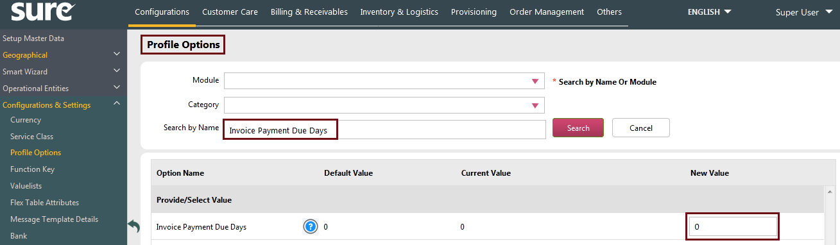

Capture Own Hardware In Order Booking
Use Capture Own Hardware In Order Booking profile option to capture customer-owned hardware item details while booking a contract in the Service Order screen.
In the Current Value box, set the value to Yes to enable/show the Customer Hardware Details section in the Service Order screen. This allows the User capturing own hardware item serial numbers while booking a contract.
In the same way, set the value to No to disable/hide the Customer Hardware Details section in the Service Order screen.
The Default Value is No.
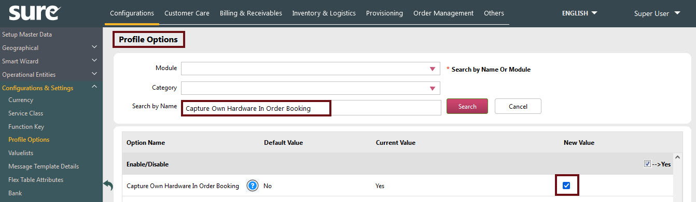

Grace Period
Use the Grace Period profile option to specify the grace period which can be given to the availed services of the customers. The grace period is the period during which the service remains active even after the actual agreement expiry date is reached.
In the Current Value box, specify the period for which the service should remain active after the actual agreement expires.
The default value is 0 (Zero).
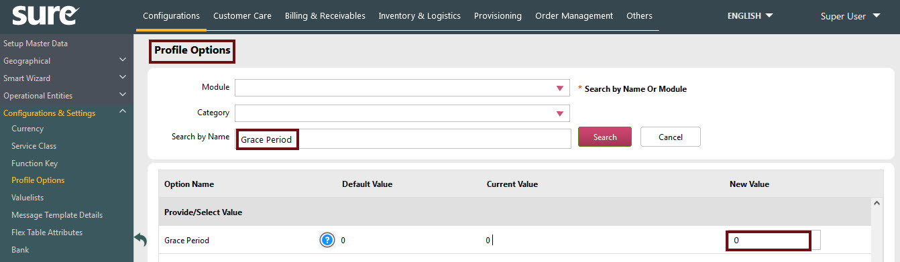

Jobs

The following is the explanation of the jobs related to the Simplified Collections:

Simplified Collection New
On scheduling this job, the system performs the actions related to the Simplified Collections based on the Customer’s collection status.
Here, the system inspects the Payment Due Date of the Customer from the Invoice table, and based on their payment due date and the configured profile option's value, the system performs the necessary simplified collections action.
Note: Here, the Email/MSG is not sent to the Customers but the necessary simplified collection action is performed.

Mail Daemon
On scheduling this job, the system sends the mail to the Customers. The mails here are based on the Simplified Collections actions described above.

Generate Payment Request
Generate Payment requests job is scheduled to generate payment requests for the customer who have given standing instructions based on their outstanding debit balance. This job is run periodically after the bill generation process. Payment requests are generally sent to the financial institution before the payment due date (in offline mode) and on the due date (in online mode).
Payment requests may be generated for a particular group of customers based on the selected standing instructions.
Note: Here, the duplicate payment requests should not be generated within the defined period/duration. Also, disconnected customers should not be picked up to generate a payment request

To schedule this job, select the job and enter parameters. Parameters specified for this job are:
- Batch ID: Select Generate Payment Request For Simplified Collection from the list.
- Batch Instance: Select the applicable Batch Instance from the list.
- Merchant Name: Select the applicable Payment Gateway from the list.

Process Payment Request
Process Payment Request job is scheduled to send the payment requests (generated in Generate Payment Request process) to the financial institutions in batches for processing.
To schedule this job, select the job and enter parameters. Parameters specified for this job are:
- Batch Id: Select Process Payment Request Batch from the list.
- Batch Instance: Select the applicable batch instance from the list.

Process Response Payment Request
Generally, response is received against each payment requests that are sent to the financial institution/gateway when Process Payment Request batch job is scheduled. Depending on the received response, Process Response Payment Request job is scheduled to process the payment requests further to make the payment.
When this job is scheduled, all the successful processed payment requests are retrieved and further processing is carried out. In this process, failed processed requests are not considered for payment. The payment entries are generated for the customers based on the success records only.
For the failed records, request may be resent to the financial institution or appropriate follow up action is taken up.

Follow Up By Usage
On scheduling this job, the system performs the actions related to the Simplified Collection based on the Customer's usage status.
After scheduling of this job, the System inspects the usage_summary_service_wise table and collects the usage percentage of the Customer and inserts a record with the usage percentage in the message_store table.

Follow Up By Trial Expiry
This job notifies the customers about the trial plans expiry. In other words, once this job is scheduled, the system sends the configured follow-up mail about the trial plan expiry to the Customers.

Manage Notifications
This screen is used to manage the notifications that are sent to the Customers. Here, the Screen only facilitates the User in making the notification status Active or Inactive. I.e. Upon making the status Active, the notifications are sent to the Customers via Email and SMS. If the status is Inactive, then the notifications are disabled and are not sent to the Customers.
The event notifications include Payment due reminders (before and after), True Prepaid Remainders (before and after), Trial Plan Remainders, Data Usage Reminders, Payment Failures, Payment Success, Renewal Reminders (before and after), Customer Onboarding, etc.
The User can also manage the Feedback notifications for different events from this screen.
Note: The User can also view the Email/SMS notification template by clicking the icon under the Email/SMS columns.
Follow these steps:
- On the Settings, click Configurations, click Message Templates, and then click Manage Notifications.
The Manage Notifications Screen appears with the list of predefined notifications.
- Toggle the Notification button ON for enabling the notification.
Note: Upon enabling the notification, the configured Email and SMS notifications are sent to the Customers.
- To disable the notification, toggle the Notification button OFF.

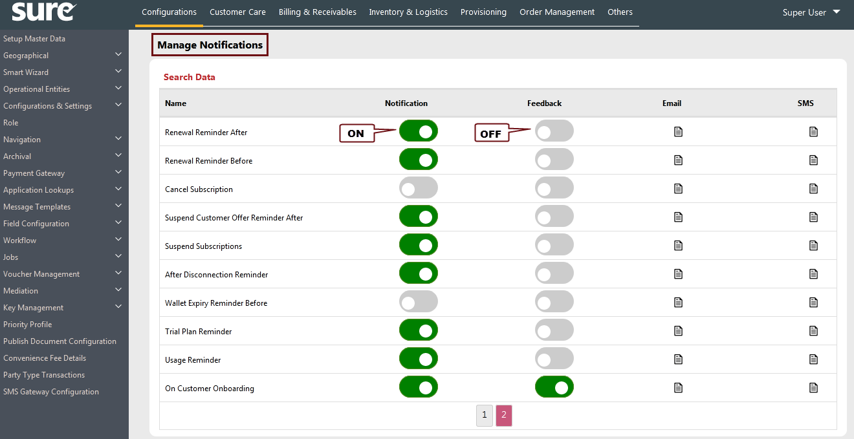

Support
For further information or any technical support, please contact:
E-mail: mqssupport@magnaquest.com, bcrm.support@magnaquest.com
Phone: +91 9866558383

Copyright

This document is the property of, and is proprietary to Magnaquest Technologies Limited (Magnaquest). It is not to be disclosed in whole or in part without the expressed written authorization of Magnaquest, and shall not be duplicated or used, in whole or in part, and shall be returned to Magnaquest upon request.
Copyright © 2020 Magnaquest Technologies Limited (Magnaquest). All rights reserved. All trademarks, trade names, service marks, and logos referenced herein belong to their respective companies.

